**NAME: ……………………………………………………………………………………………………………………………………….**

**JINJA MODERN SECONDARY SCHOOL**

**END OF TERM III EXAMINATIONS 2023**

**S.3CHEMISTRY PAPER ONE**

**2 HOURS.**

**-ATTEMPT ANY FOUR ITEMS**

**-EACH ITEM CARRIES 20 SCORES**

1.Fatuma was passing near a mango tree on her way home from school when she saw a ripe mango. she picked some stones and threw them at the mango, unfortunately the stone hit the swarm of bees and suddenly she was attacked by bees that stung her severely. She sustained a lot of pain and swellings. Suggest ways of reducing her pain and the swellings.

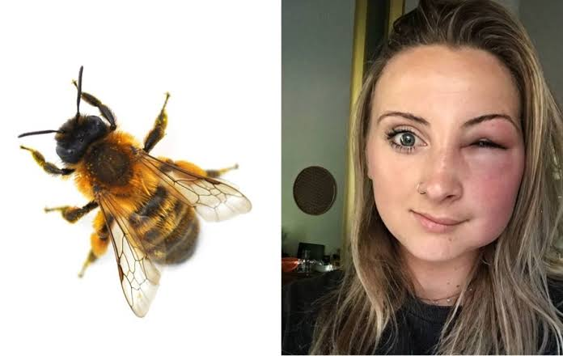

2. Your chemistry teacher has provided your class with the following; dilute acids, Magnesium ribbon, Copper turnings, Zinc granules and Iron filings. Write an investigation using a scientific method that you can carry out to place the elements in order of reactivity.

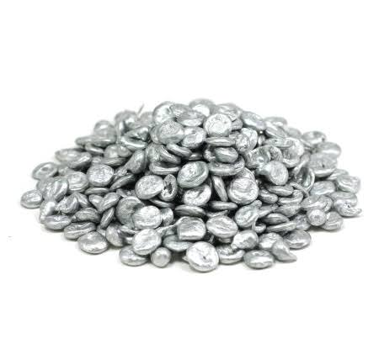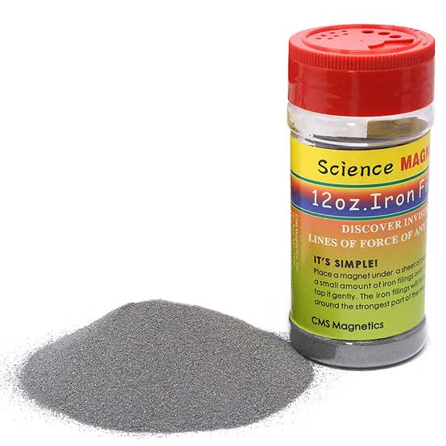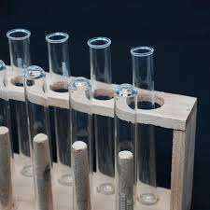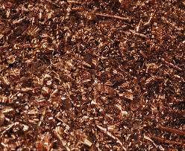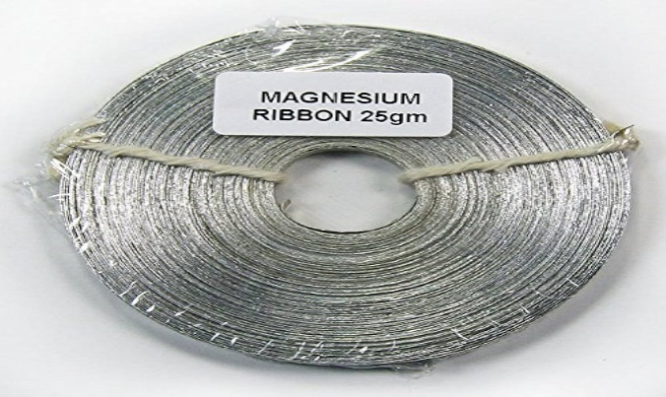

3. Wambi wants to build a permanent house, but lacks adequate information about the materials to use during the construction of his house.

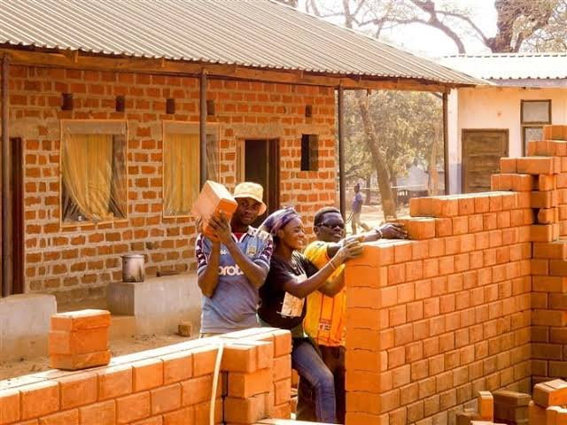

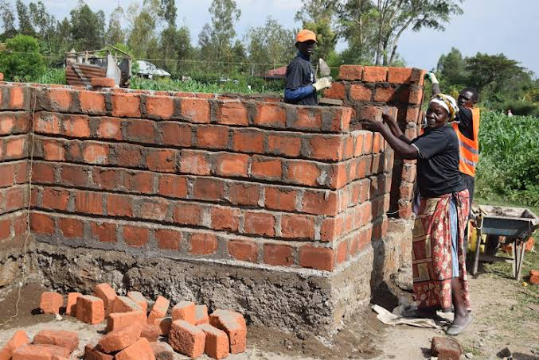

As a student of Chemistry, give a written advice to Wambi on the suitable materials he can use to construct his house.

4. Crude oil deposits were discovered in Bunyoro region in Uganda recently. This discovery has brought fears among people in the area. Among the many fears,some Banyoro say crude oil is a bad omen, others say it will lead to human sacrifice of residents of the community.



As a member of this community where crude oil has been discovered, and as a student with knowledge about fossil fuels, learners have been asked to chair a meeting with the LC 1 Chairman and his executive to help dispel these fears about fossil fuels in the community. Prepare a speech that you will present at this meeting.

**MERRY CHRISMAS & HAPPY 2024**